Data Integration and Transformation Report for Apparel & Textiles Industry

Submitted By: Manya Gupta
Week: Week 3
Project: Data Integration and Transformation
Tools Used:
- Python
- Google Colab
- Pandas
- NumPy

Table of Contents
- Introduction
- Objective
- Data Sources
- Dataset Comparison
- Data Transformation Strategy
- Data Integration Strategy
- Data Validation
- Challenges Encountered
- Solutions Implemented
- Conclusion
- References

1.Introduction
Data integration is the process of collecting data from multiple sources and combining it into a consistent and meaningful format for analysis. In real-world business environments, data is often stored in different systems, databases, and file formats. These datasets may contain different structures, naming conventions, missing values, and inconsistent data types, making direct analysis difficult. Before any meaningful insights can be generated, the data must be cleaned, standardized, transformed, and validated.
In the apparel and textiles industry, organizations collect information from various sources such as e-commerce websites, product catalogs, customer reviews, inventory systems, and market research platforms. Integrating these diverse datasets enables businesses to gain a comprehensive understanding of product performance, consumer preferences, pricing strategies, and market trends. This integrated view supports better decision-making in areas such as inventory management, marketing, demand forecasting, and product development.
This report presents the process of integrating two publicly available datasets related to the apparel and textiles industry. One dataset focuses on product catalog information, while the other provides customer preference and recommendation data. Due to differences in structure and format, the datasets required cleaning, transformation, normalization, and validation before they could be used together in a unified analytical framework.

2.Objective
The objective of this project is to simulate a real-world data integration workflow by collecting data from multiple public sources, transforming and standardizing the datasets, and preparing them for future analysis. The project also aims to demonstrate best practices in data cleaning, normalization, reconciliation, and validation while maintaining data quality and consistency.

3. Data Sources
Here, explaining the two datasets separately.

Dataset 1
- Source: OpenML
- Format: ARFF
- Converted to CSV using Python
- Contains dress recommendation attributes
Include features:
- Style
- Price
- Rating
- Season
- Material
- Recommendation
Explanation: This dataset provides information about customer preferences and dress characteristics, making it useful for understanding consumer behavior.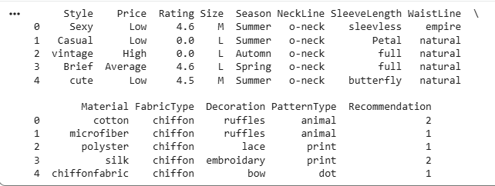

Dataset 2
- Source: Kaggle
- Format: CSV
Contains:
- ProductID
- ProductName
- ProductBrand
- Gender
- Price (INR)
- Description
- PrimaryColor
Explanation:This dataset represents product catalog information including pricing, brands, and product descriptions.
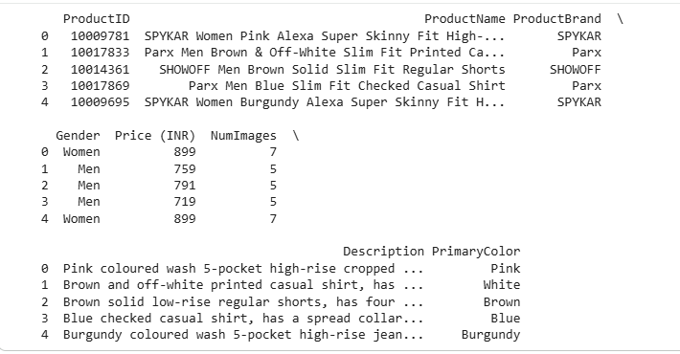
4. Dataset Comparison

Feature | OpenML | Kaggle
File Format | ARFF | CSV
Data type | Consumer Preferences | Product Catalog
Numeric Column | Rating | Price
Categorial Column | Style, Season | Brand, Gender
Missing Values | Yes | Yes
Although both datasets belong to the apparel and textiles domain, they differ in structure, attributes, and file format. These differences require transformation and standardization before they can be used together.
5. Data Transformation Strategy

a) Loading datasets
Used pandas.read_csv() after converting the ARFF file to CSV.

b) Cleaning
- Removed extra spaces.
- Standardized column names.
- Converted text to a consistent format.
- Handled missing values.

c) Removing duplicates
Explain why duplicates were removed.

d) Mapping
This is where you explain the BrandCategory mapping you created.
ProductBrand | BrandCategory
SPYKAR | Fashion
Police | Accessories
Homesake | Home Decor
A mapping dictionary was created to categorize brands into broader product categories. This transformation improves consistency and supports grouped analysis.
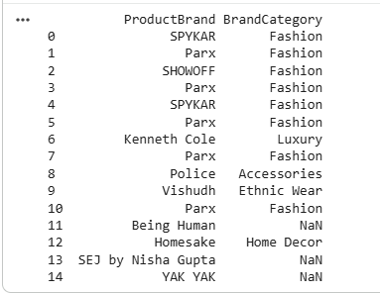
6. Data Integration Strategy
Both datasets belong to the apparel and textiles domain but represent different aspects of the business. The OpenML dataset focuses on customer preferences and product recommendations, whereas the Kaggle dataset provides product catalog information. Since the datasets do not share a common unique identifier, a direct row-level merge was not appropriate. Instead, both datasets were standardized individually and integrated conceptually by preparing them within a unified analytical framework. This approach preserved data quality while enabling complementary analysis.
7. Data Validation
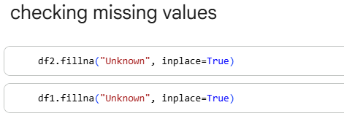
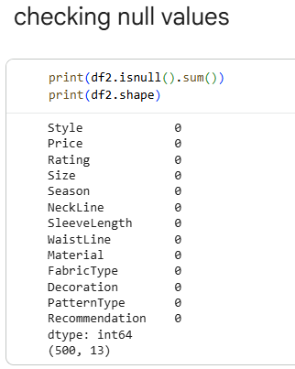
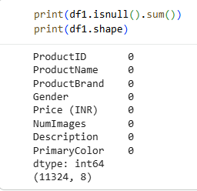

8. Challenges Encountered
During the data integration and transformation process, several practical challenges were encountered. The first challenge was that the two selected datasets were obtained from different public sources and were available in different file formats. The OpenML dataset was downloaded in ARFF format, while the Kaggle dataset was available in CSV format. This required converting the ARFF file into a format that could be processed using Pandas.
Another challenge was the difference in the structure and schema of the datasets. The OpenML dataset contained attributes such as Style, Season, Material, Rating, and Recommendation, whereas the Kaggle dataset included ProductID, ProductName, ProductBrand, Gender, Price (INR), Description, and PrimaryColor. Since the datasets did not share a common unique identifier, performing a direct row-level merge was not possible.
The datasets also contained missing values, inconsistent text formatting, and byte-encoded values in the OpenML dataset, which required decoding before analysis. In addition, some brands in the Kaggle dataset were not categorized initially, resulting in missing values during the brand mapping process. Ensuring data consistency while preserving the original information was an important consideration throughout the project.

9. Solutions Implemented
To overcome these challenges, the OpenML dataset was first converted from ARFF format to CSV using Python. Byte-encoded values were decoded into readable text, and column names were standardized by removing extra spaces and applying consistent naming conventions.
Missing values were identified using Pandas functions and handled appropriately based on the type of data. Duplicate records were checked and removed to improve data quality. Text values such as style names and gender categories were normalized to maintain consistency across the datasets.
A mapping dictionary was created to classify product brands into broader categories such as Fashion, Accessories, Luxury, Home Decor, Ethnic Wear, and Lingerie. This transformation enriched the Kaggle dataset and demonstrated the use of data mapping techniques. Since a direct merge was not technically appropriate due to the absence of a common key, both datasets were standardized individually and integrated conceptually as complementary sources of apparel-related information. Finally, validation checks were performed by verifying data types, dataset dimensions, missing values, and duplicate records to ensure that the transformed datasets were accurate and suitable for future analysis.

10. Conclusion
This project successfully demonstrated the process of data integration and transformation using two publicly available datasets from the apparel and textiles industry. The datasets were collected from different sources, cleaned, standardized, transformed, and validated using Python and the Pandas library in Google Colab. Throughout the project, special attention was given to maintaining data quality by handling missing values, removing duplicate records, normalizing text fields, and applying mapping techniques to improve consistency.
Although the two datasets could not be merged directly because they did not share a common unique identifier, they were successfully prepared as complementary datasets within a unified analytical framework. This approach reflects a practical real-world data engineering scenario where not all datasets can be combined through direct joins. The project highlights the importance of data transformation, normalization, reconciliation, and validation in creating reliable datasets for business intelligence and future analytics. Overall, this assignment enhanced my understanding of data integration techniques and demonstrated how careful data preparation supports accurate, meaningful, and data-driven decision-making in the apparel and textiles industry.

